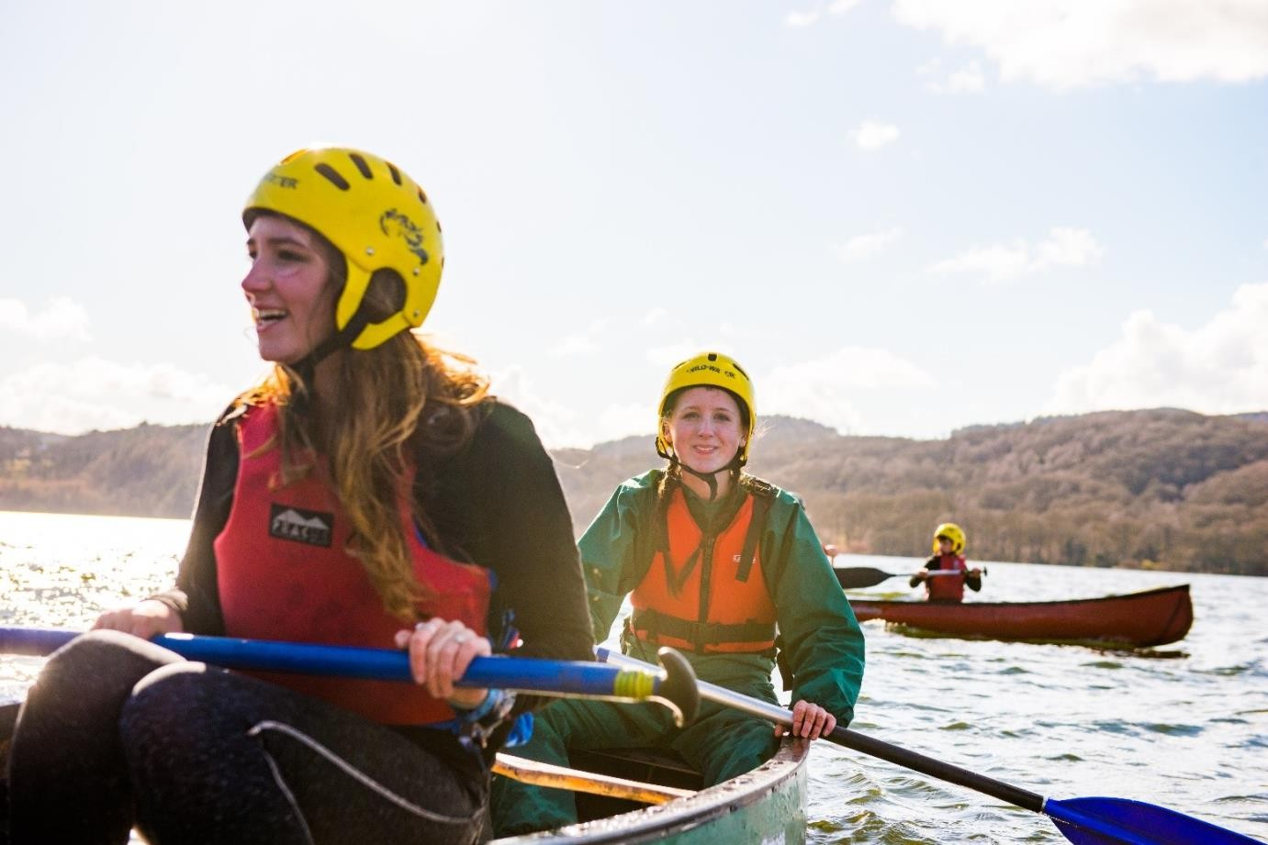

**Blaenau Gwent District Scouts**

District Leadership Team Applicant Pack:

Support Team Lead

About us…

Overview of Scouting

We are the UK’s biggest mixed youth organisation. We change lives by offering 4- to 25-year-olds fun and challenging activities, unique experiences, everyday adventure and the chance to help others so that we make a positive impact in communities.

Scouts help children and young adults reach their full potential. Our members gain valuable skills for life including teamwork, time management, leadership, initiative, planning, communication, self-motivation, cultural awareness and commitment. We help young people to get jobs, save lives and even change the world.

What do Scouts do?

Scouts take part in a wide range of activities as diverse as kayaking, abseiling, expeditions overseas, photography, climbing and zorbing. As a Scout you can learn survival skills, first aid, computer programming or even how to fly a plane. There’s something for everyone. It’s a great way to have fun, make friends, get outdoors, express your creativity and experience the wider world.

What do volunteers do?

This everyday adventure is only possible thanks to our team of adult volunteers, who support Scouts in a wide range of roles from working directly with young people, to helping manage a local community-based Group, to being a charity Trustee. We help volunteers get the most out of their experiences at Scouts by providing opportunities for adventure, training, fun and friendship.

Our award-winning training scheme for volunteers means that adults get as much from Scouts as young people. Our approach focuses on what you want to get out of volunteering with Scouts, while respecting how much time you can offer. Over 90% of Scout volunteers say that their skills and experiences have been useful in their work or personal life.

Key facts and figure

##### The Scout Association is a UK charity founded in 1907 and now boasts a membership of over 620,000 young people and adult leaders. We are the largest mixed youth movement in the UK. Scouting activity is delivered through 7,000-plus community

**based Scout Groups nationwide.** Scouting is widely recognised and is one of the most trusted charities in the UK, giving it a significant level of influence and responsibility.

Scouting’s greatest strength lies in its grass roots. It is locally that Scouting is best able to identify and work directly with young people most in need. We believe that through the everyday adventure of Scouting, young people and adult volunteers regularly experience new challenges that enrich and change their lives

Our strategy…

### By 2025 we will have prepared more young people with skills for life, supported by amazing leaders delivering an inspiring programme. We will be growing, more inclusive, shaped by young people and making a bigger impact on our communities.

Further information on our strategic objectives is provided on our website at [www.scouts.org.uk/ourplan](http://www.scouts.org.uk/ourplan)

Scouting’s

Fundamentals

## Our mission

Scouting exists to actively engage and support young people in their personal development, empowering them to make a positive contribution to society.

## Our values

As Scouts, we are guided by these values:

* Integrity
* Respect
* Care
* Belief
* Co-operation

Further information on our fundamentals, including details of our values, are provided on our website at <http://scouts.org.uk/about-us/key-policies/fundamentals-of-scouting/>

## Our key policies

In common with all members in Scouting, the Chief Commissioner of Wales is required to promote and follow our key policies. The policies cover:

* Child Protection
* Equal Opportunities
* Religion
* Safety

These policies are fully explained on our website at <http://scouts.org.uk/about-us/key-policies/>

**Bleanau Gwent District** is part of Gwent Scout County. It is led by the District Lead Volunteer, a District Leadership Team and governed by a Board of Trustees. Blaenau Gwent Scouts consists of 5 Scout Groups, 1 Explorer Scout Unit.

**Number of Young People:140**

**Number of Adults: 68**

# Introducing the leadership team

roles…

We want to make volunteering easier and more fun, so that more people will want to volunteer, and our current volunteers will want to stay. Doing this is how we will achieve our North Star - more young people gaining skills for life.

We want flexible volunteering to be a reality. To do this, we’re using team descriptions. Unlike role descriptions, where one volunteer takes on specific responsibilities (this can be a barrier for some volunteers joining or staying in Scouts), this approach means we can share the load among the team.

We're making it clear that volunteers can get involved with just the tasks that work for their skills, interests and free time. Teams can decide how to split the tasks up, according to who's in the team and what the local needs are.

Our new approach makes it easier for our current teams, as volunteers can give their time in a more sustainable way. It helps volunteers build knowledge, experience, and confidence. And it makes it easier for them to change their involvement when their circumstances change. As such, they stay volunteering for longer. And in the future, more volunteers will want to join Scouts and give their time as part of a flexible team.

##### We are now looking to recruit District Team Leaders for the following teams:

* The **District Support Team** which gives tools and resources to help Scouts run smoothly in the district.

The team leaders of the above teams will also be members of the District Leadership Team, which leads and inspires volunteers to give young people great experiences and skills for life. They will be involved in building and leading their own teams under the District of the District Lead Volunteer.

# What leading a team means…

Each team can have at least one Team Leader. Leadership Teams are led by a Lead Volunteer and made up of other Team Leaders and Leadership Team Members. In Districts and Counties, Youth Leads are also members of the Leadership Team.

Team Leaders and Lead Volunteers work with Team Members to share tasks out and make sure the team runs smoothly.

##### Create a positive team environment

* Agree how Team Description tasks are shared among Team Members by considering their skills, interests, and availability.
* Make sure the team puts young people at the heart of what they do, so they can create inspiring teams and brilliant programmes.
* Make sure the team is open and inclusive and adapt team activities and tasks to be accessible to everyone.
* Make sure everyone in the team is safe and following safety and safeguarding procedures.

##### Help volunteers find what they need

* Help Team Members find learning and networking opportunities.
* Encourage Team Members to share what’s happening in the team and find out where they might need

support.

* For Lead Volunteers in Districts and Counties, make sure volunteers have the permits or accreditations they need to carry out specific, allocated tasks (where relevant).

##### Attract and welcome new volunteers

* Help recruit new volunteers (with the Leadership Team and Volunteering Development Team) so there’s

always enough people in the team.

* Make sure new volunteers are warmly welcomed and complete their learning.

##### Reflect and review

* Set up regular team self-reviews (at least once a year) to give everyone a chance to reflect on successes, and plan for the future.
* Carry out individual reviews with each Team Member. For Section Teams, they’re held by a member of the

Group Leadership Team (for Squirrels, Beavers, Cubs and Scouts) or 14-24 Team (for Explorers).

# District Leadership Team

Purpose

The District Leadership Team leads and inspires volunteers to give young people great experiences and skills for life. They make sure their District teams are organised, have enough volunteers, and can deliver a great programme.

Who's in the team

* District Lead Volunteer
* District Youth Leads
* Programme Team Leader
* Volunteering Development Team Leader
* Support Team Leader
* Group Lead Volunteers
* 14–24 Team Leaders

Tasks for the whole team

Make sure teams across the District:

* Work well on their own (and together).
* Are inclusive and reflect the demographics of their local area.
* Have the resources, skills and enthusiasm to deliver the Scouts strategy
* Volunteers in the District’s teams have the skills and experience to fulfil their safety and safeguarding responsibilities, including by keeping up to date with changes, and being aware of safety and safeguarding concerns in the District.
* Volunteers are aware of Our Volunteering Culture, reflect on it, commit to it, and apply it in their teams.

Allocated tasks

* Help with recruitment for the District Trustee Board Chair, District Team Leaders, District Youth Lead and Group Lead Volunteer roles.
* The District Youth Lead works with teams across the District to make sure they’re shaped by young people.

Other responsibilities

Make sure safeguarding, safety and data incidents and complaints are managed well. The Lead Volunteer will be responsible for responding to this, or for appointing someone else in the District to do this.

**Support Team**

**Purpose**

The District Support Team gives tools and resources to help Scouts run smoothly.

**Who's in the team**

* Support Team Leaders
* Support Team Members

Other volunteers are automatically members of this team because of their roles in Scouts:

* Team Leaders of any District Support Team sub-teams. For example, Campsite Service Team.

**Allocated tasks**

Support Scouts locally by engaging with the community:

* Create and look after relationships with other organisations that can help Scouts grow locally and further our reach into more communities.
* Create a positive image of Scouts in the local community. For example, through local media, showing that Scouts is inclusive and open to all.
* Plan and run fundraising events when they’re needed.

Open new provision:

* Work with Groups and other District teams to open, close, or merge Sections (depending on local demand).
* Support effective processes:
* Carry out finance administration. This could include paying expenses/invoices, tracking income/expenditure against the budget, and buying badges/awards/uniform for the District.
* Set up and look after email, web, social media, and web meeting systems for the District (and, if appropriate, for Groups and Units).
* If there are staff, make sure they’re properly managed and well recognised. This includes following employment law and acting as a responsible employer in line with Scout values.
* Look after joining enquiries across the District and help Section Teams understand any additional needs of young people joining Scouts.
* Governance administration for the Trustee Board, to include meeting preparation, minute taking and AGM organisation.
* Look after property and equipment:
* Check bookings and maintenance for any District-owned property and equipment (including 14-24 Sections).
* Oversee meeting places for 14-24 Sections (whether they’re rented, leased, or owned).

**Other responsibilities**

We expect that members of this team will take part in regulated activity.

**Support Team Structure**

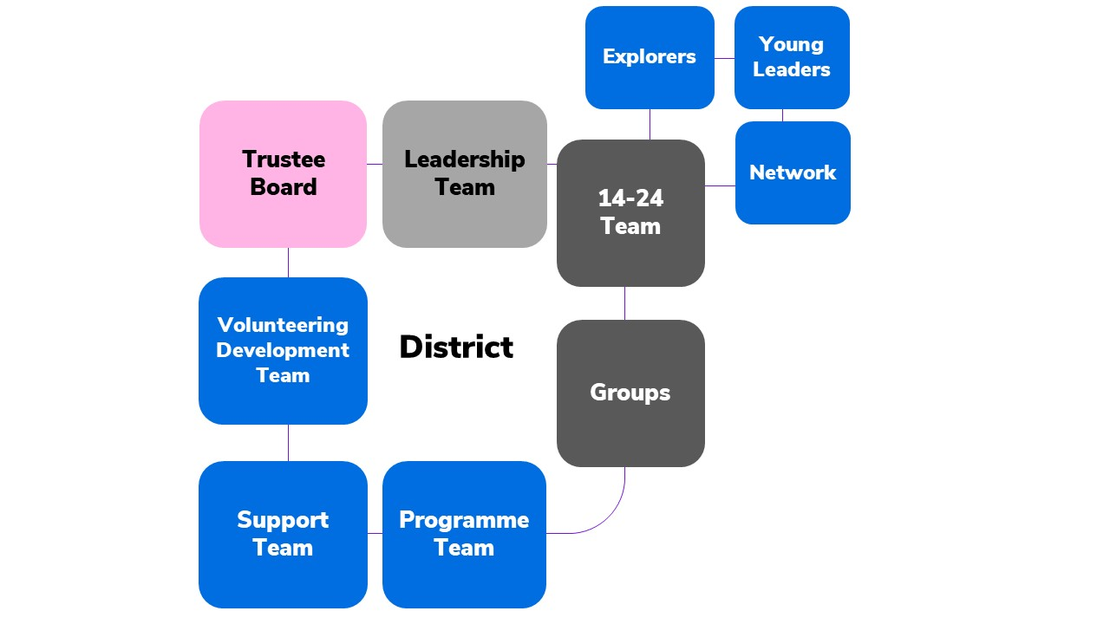

**Person specification**

|  |  |  |  |
| --- | --- | --- | --- |
| **Knowledge and experience:** |  | | |
| Ability to manage adults effectively | Essential | | |
| Understanding of the challenges of working in the voluntary sector | Desirable | | |
| Experience of working with young people and/or community work with adult groups | Desirable | | |
| Experience of working in the Scout or Guide Movements as an adult | Desirable | | |
| **Skills and abilities:** |  | | |
| Excellent written and oral communication skills | Essential | | |
| Provides advice and guidance effectively to others | Essential | | |
| Provides inspirational leadership for the District Team | Essential | | |
| Provides strategic direction for the District Team | Essential | | |
| Motivate adults volunteering in the District Team | Essential | | |
| Can build, maintain and facilitate effective working relationships with a wide range of people | Essential | | |
| Enables others to identify issues, clarify objectives, develop attainable objectives and gain the necessary skills and confidence to work as an effective team | Essential | | |
| Ability to negotiate compromises | Essential | | |
| Plans, manages and monitors own tasks and time | Essential | | |
| Can construct and implement long-term plans that improve and expand the Scouting offered to young people, and identify any training, resources and other needs required to undertake this work | Essential | | |
| Can use basic computer software | Essential | | |
| **Personal qualities:** |  | | |
| An understanding of the needs of adult volunteers | Essential | | |
| Flexible approach | Essential | | |
| Self-motivated | Essential | | |
| Able to work as part of a team and promote good teamwork | Essential | | |
| Resourceful, energetic, and enthusiastic about the job | | Essential |
| Acceptance of the fundamentals of the Scout Movement | | Essential |

**Nomination Form**

If you think you know the right person for this District Support Team Volunteer role, please complete the nomination form below. Nominating an individual does not commit them to applying, but, if they choose to, they will be required to complete a more thorough application form.  Privacy Statement - This form is used to collect information about you for the purpose of volunteer recruitment. This is to be used by Blaenau Gwent Scouts for this role. As part of this form we collect personal data, this detail is required so that we can identify you, the nominator and assess the skills of the nominee for the role. We don't share your personal data provided in this form with any third parties outside of the Scouts. We take your personal data privacy seriously. The data you provide to us is securely stored on secure online storage. For further detail please visit our [Data Protection Policy](https://www.scouts.org.uk/about-us/policy/data-protection-policy/)[.](https://drive.google.com/file/d/1yw6rJphVqCF8VXItNVJehGtm329sq_Gz/view) We will keep the data we capture from this form for only as long as necessary. For further detail on our retention periods please visit our [Data Retention Policy](https://www.scouts.org.uk/about-us/policy/data-retention-policy/)[.](https://drive.google.com/file/d/13ZErqpwJtLP5H2min68O32SfXzpnlYNg/view)

**Nominee’s details**

|  |  |
| --- | --- |
| Name |  |
| Telephone number |  |
| Email address |  |
| Please outline why you felt motivated to nominate this person for the role of Group Lead Volunteer: | |
|  | |

**Your details**

|  |  |
| --- | --- |
| Nominated by |  |
| Telephone number |  |
| Email address |  |

|  |  |
| --- | --- |
| Please return this form to: | Gareth.haywood@bgscouts.org.uk |
| The closing date for receiving nominations is: | 30th May 2025 |

**Application Form**

If you are interested in applying for this District Support Team Volunteer role, please complete the application form below.

|  |  |
| --- | --- |
| Privacy Statement - This form is used to collect information about you for the purpose of volunteer recruitment. This is to be used by Blaenau Gwent Scouts for this role. As part of this form we collect personal data, this detail is required so that we can identify you, the nominator and assess the skills of the nominee for the role. We don't share your personal data provided in this form with any third parties outside of the Scouts. We take your personal data privacy seriously. The data you provide to us is securely stored on secure online storage. For further detail please visit our [Data Protection Policy](https://www.scouts.org.uk/about-us/policy/data-protection-policy/)[.](https://drive.google.com/file/d/1yw6rJphVqCF8VXItNVJehGtm329sq_Gz/view) We will keep the data we capture from this form for only as long as necessary. For further detail on our retention periods please visit our [Data Retention Policy](https://www.scouts.org.uk/about-us/policy/data-retention-policy/)[.](https://drive.google.com/file/d/13ZErqpwJtLP5H2min68O32SfXzpnlYNg/view) | |
| Name |  |
| Telephone number |  |
| Email address |  |
| Please outline why you want to apply for the role of District Support Team Volunteer role: | |
|  | |
| Please briefly explain why you would be suitable for this role, including professional and voluntary experience, within or outside Scouting (refer to role description): | |
|  | |
| Please describe the skills you would bring to this role (refer to person specification): | |
|  | |
| Please return this form to: | Gareth.haywood@bgscouts.org.uk |
| The closing date for receiving nominations is: | 30th May 2025 |